=>how to run remix by using sepolia testnet

1.go to metamask, turn on show test networks
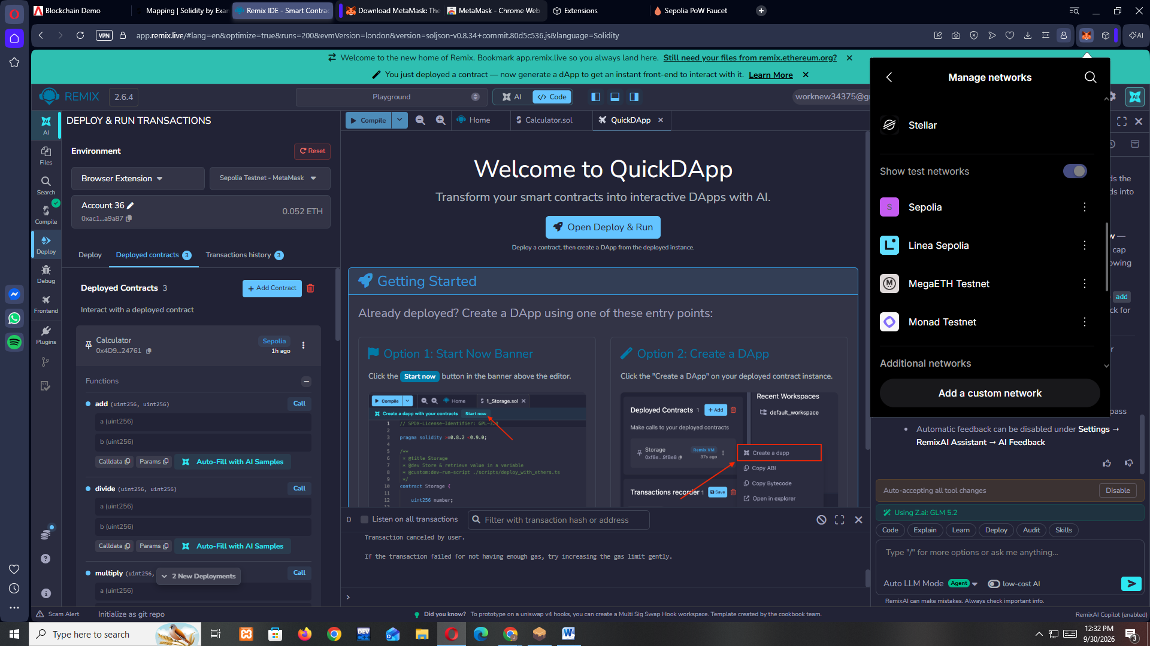

2.change the network to sepolia

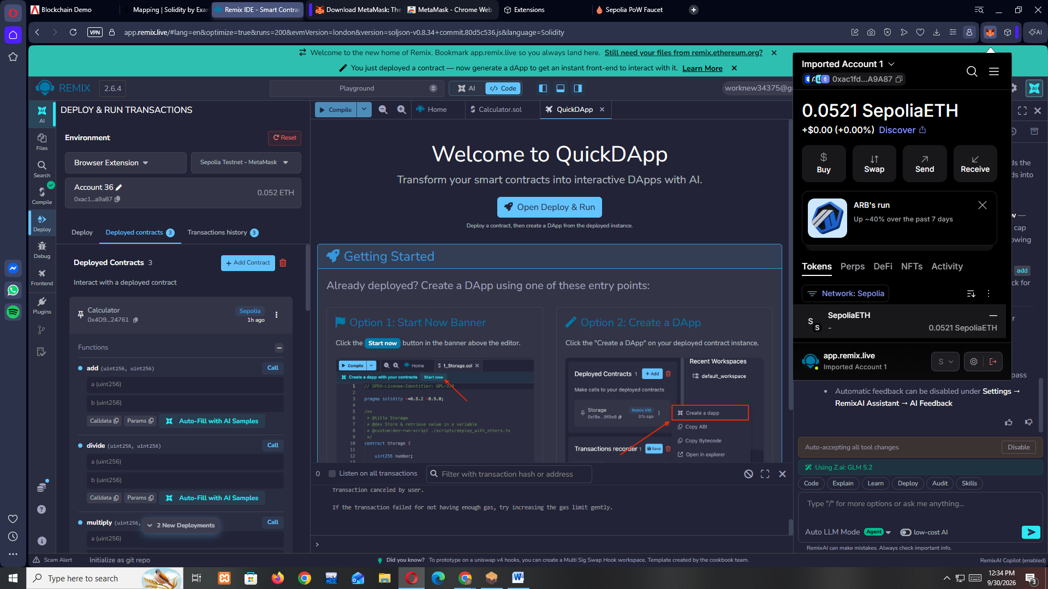

3.click on that account ,then click on view asset in explorer

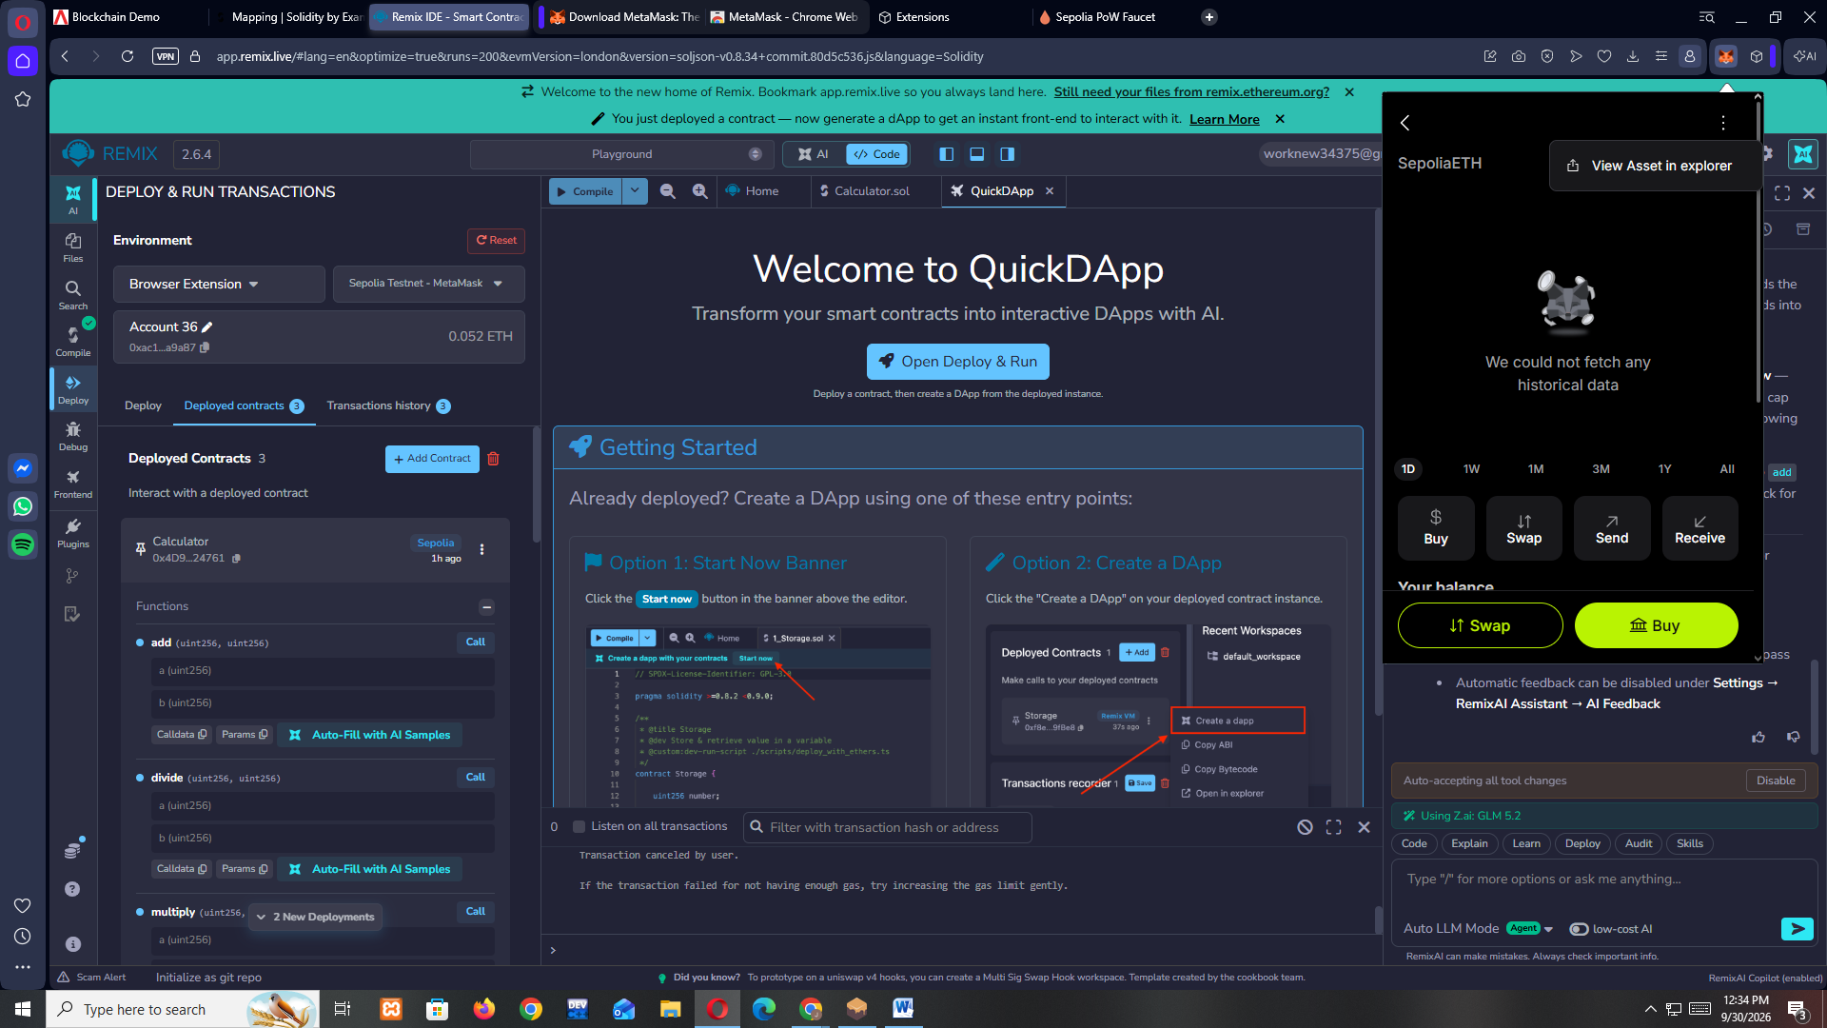

4.you will see the below window , select the address from that

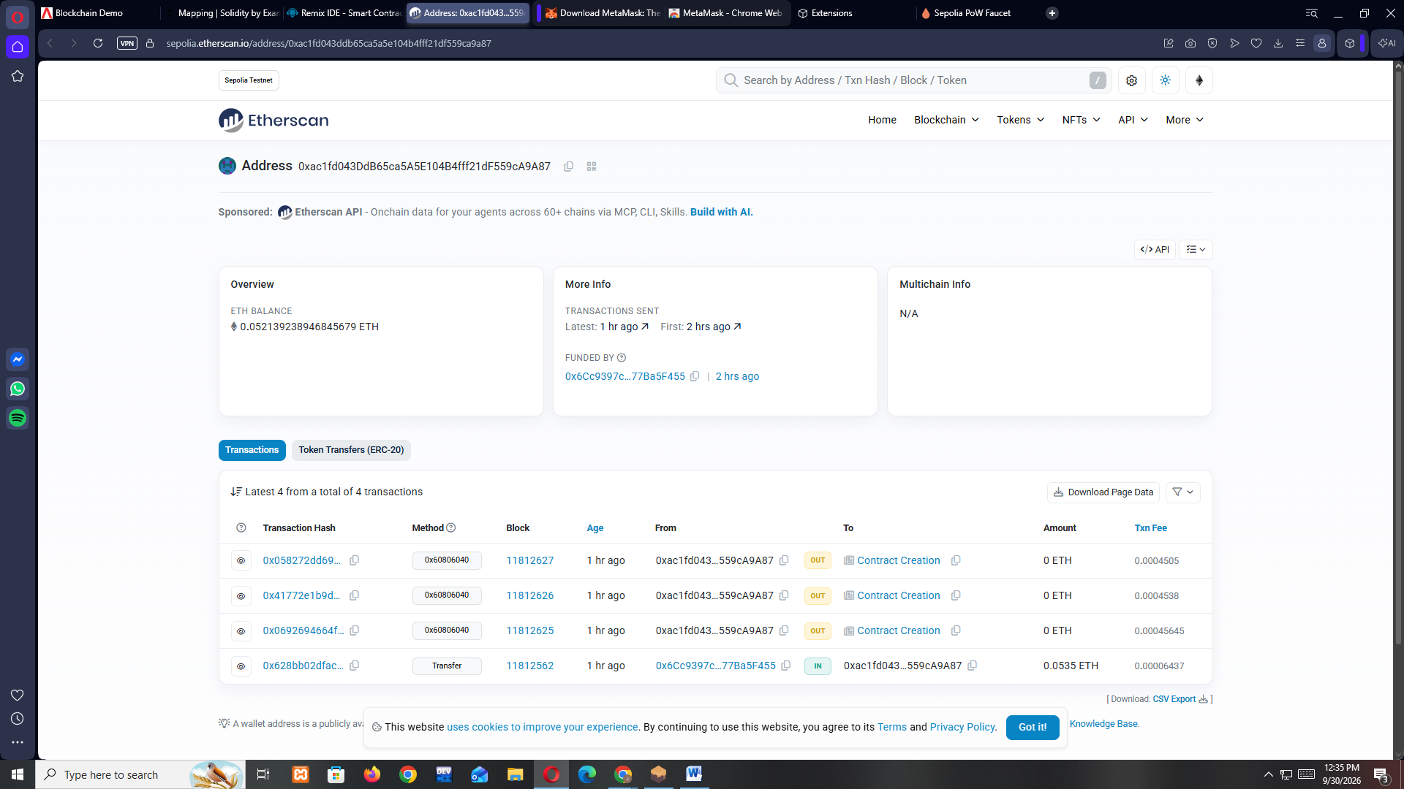

5.go to https://sepolia-faucet.pk910.de , paste the address of sepolia account and click on start mining mine atleast 0.05 sepeth

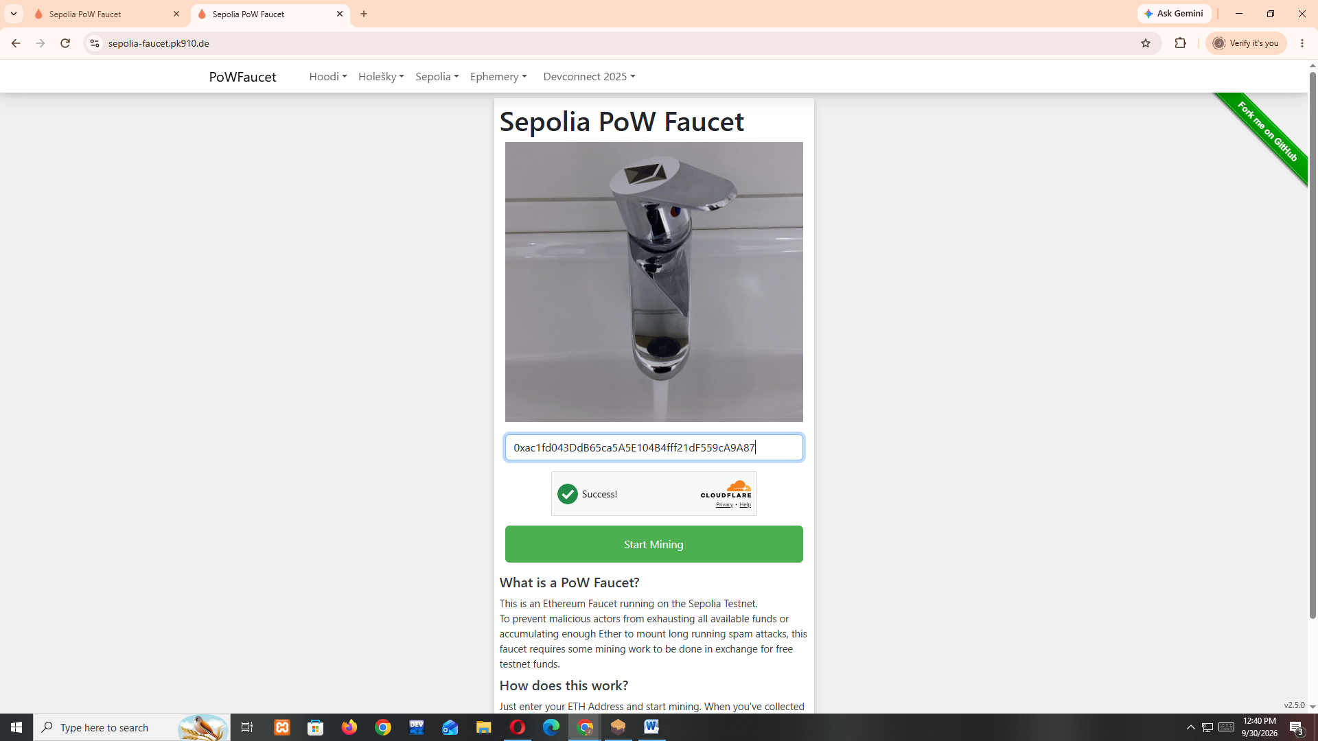

6.now you will be able to see the mined sepoliaETH in the metamask account like below

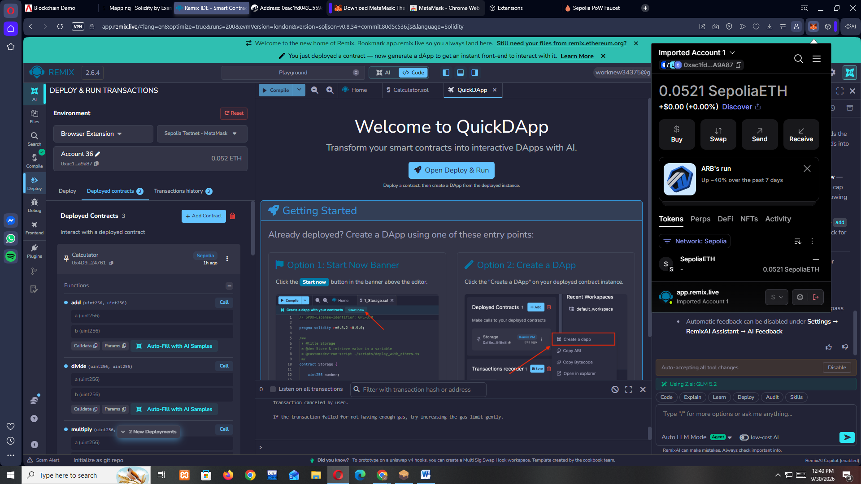

7.open remix select the calculator contract we had created earlier, compile

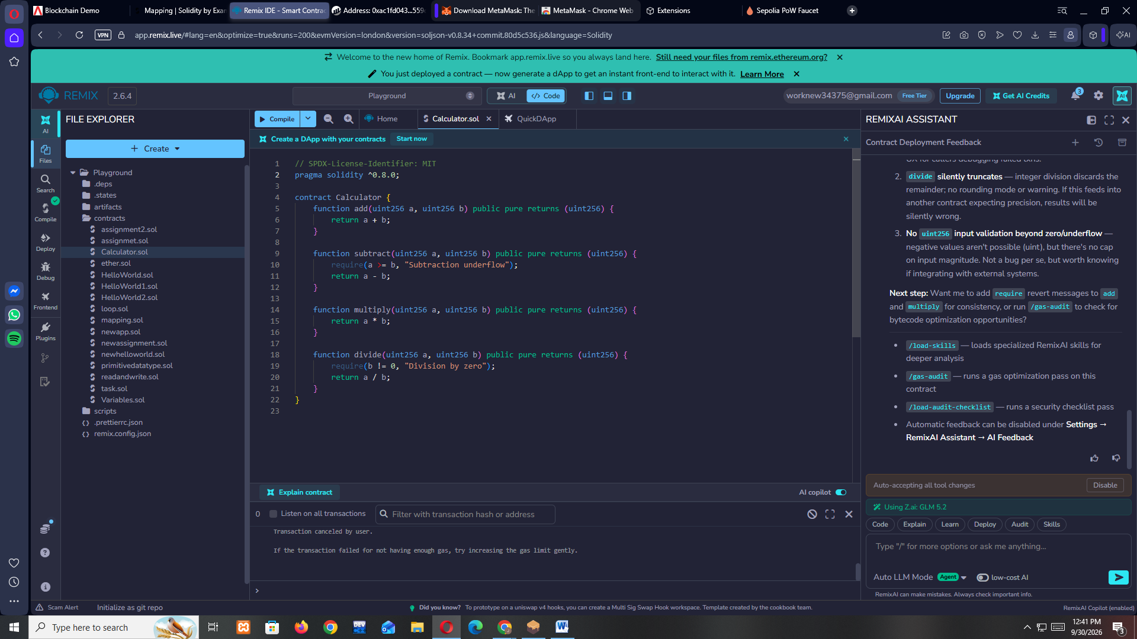

8.go to deploy and change the environment to browser extension and sepolia testnet – metamask , like the below image

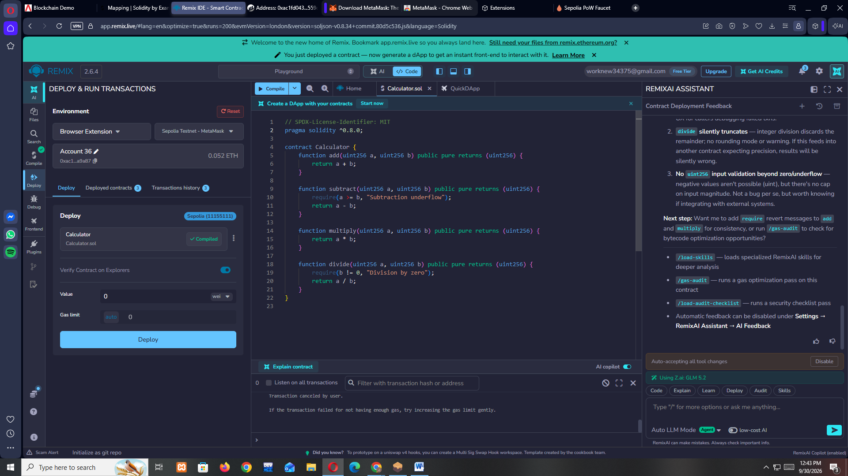

9.now click on deploy , it will deploying using the sepoliaETH we has just mined,

